ARCHITHA OJHA
BATCH-41
2303A52170
Lab 3: Application for TGNPDCL – Electricity Bill Generation Using Python & AI Tools:
Task 1: AI-Generated Logic for Reading Consumer Details :

Task Description
Use an AI tool (GitHub Copilot / Gemini) to generate a Python program that:
• Reads:
o Previous Units (PU)
o Current Units (CU)
o Type of Customer
• Calculates units consumed
• Implements logic directly in the main program (no functions)

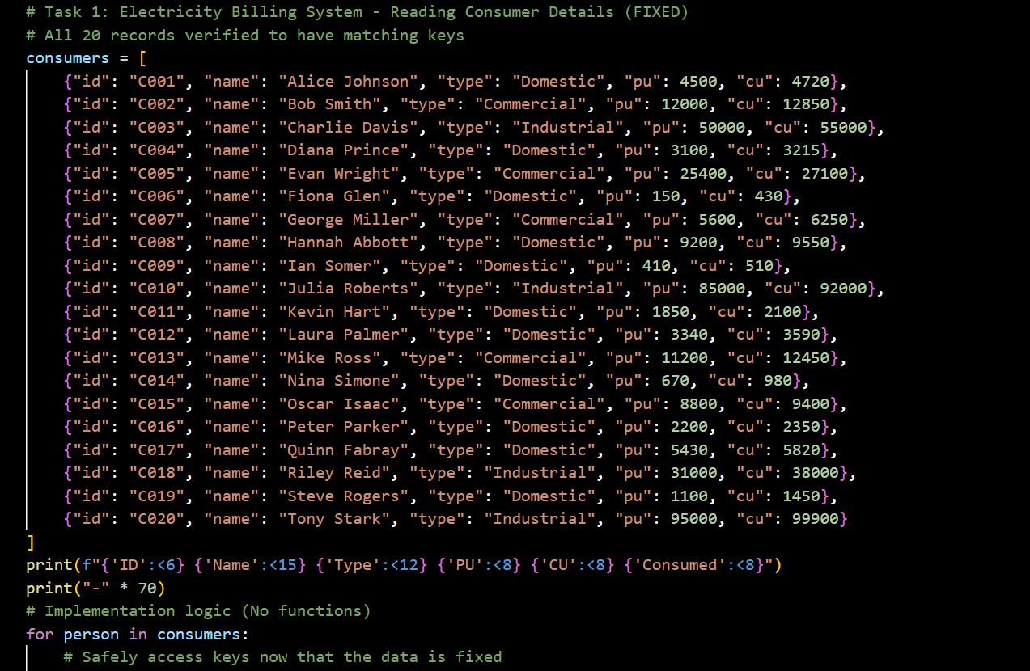

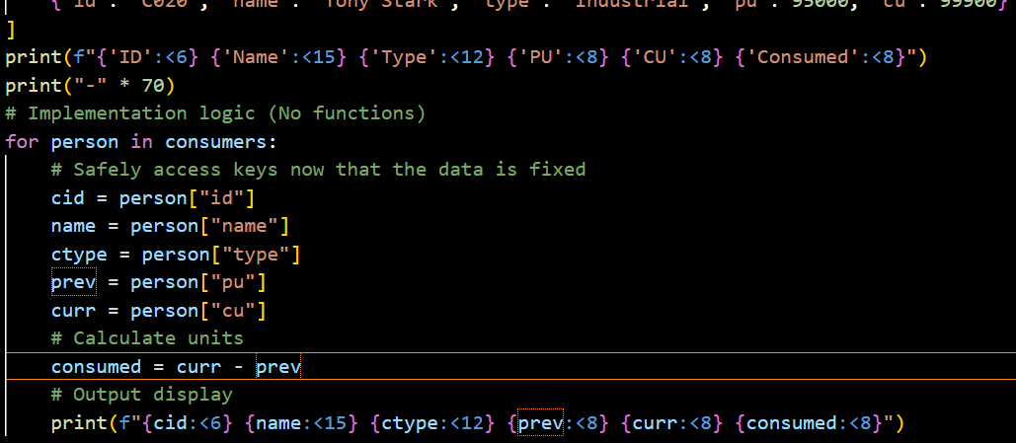

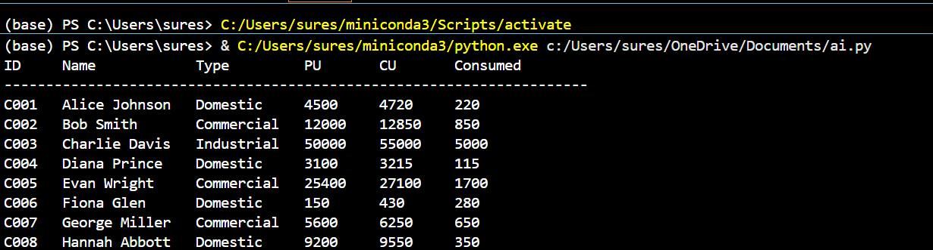

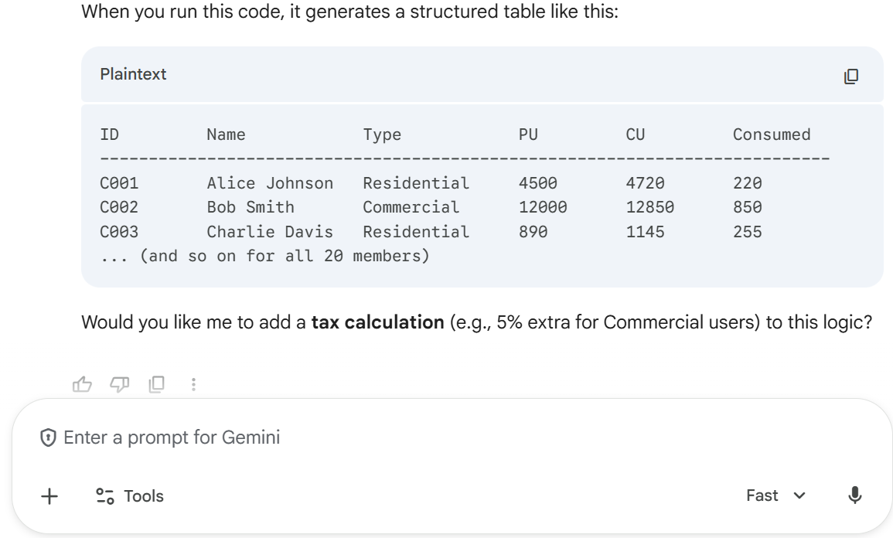

Task 2: Energy Charges Calculation Based on Units Consumed
Scenario
Energy charges depend on the number of units consumed and customer type.
Task Description
Review the AI-generated code from Task 1 and extend it to:
• Calculate Energy Charges (EC)
• Use conditional statements based on:
o Domestic
o Commercial
o Industrial consumers
• Improve readability using AI prompts such as:
o “Simplify energy charge calculation logic”
o “Optimize conditional statements”

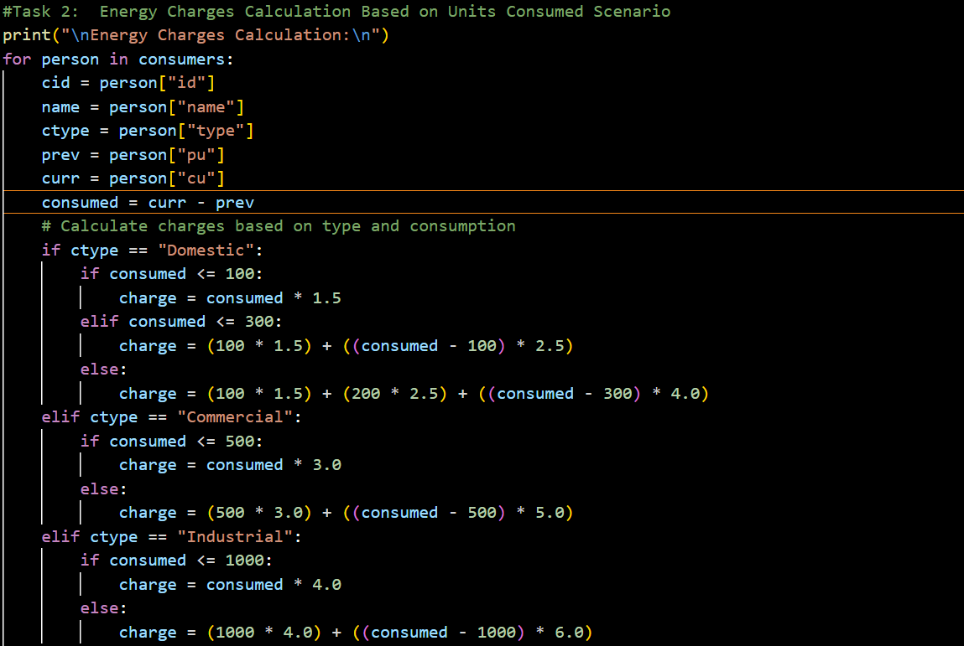

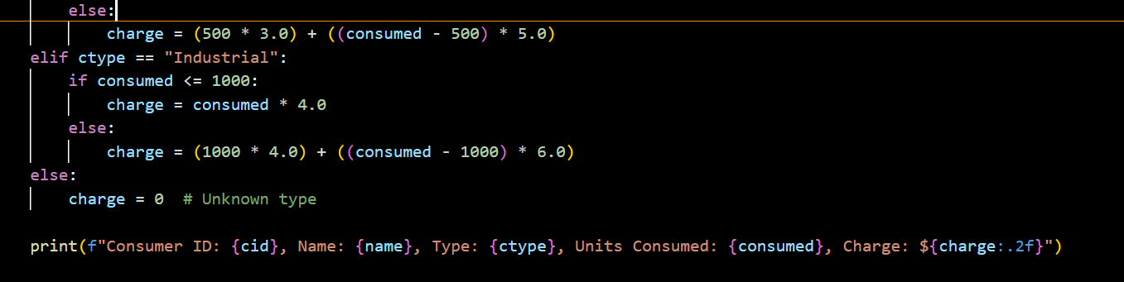

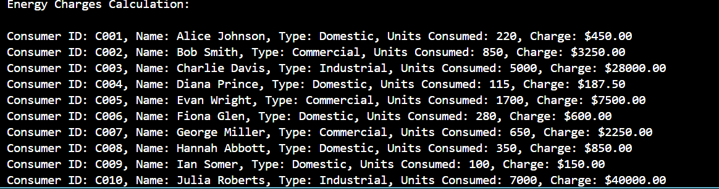

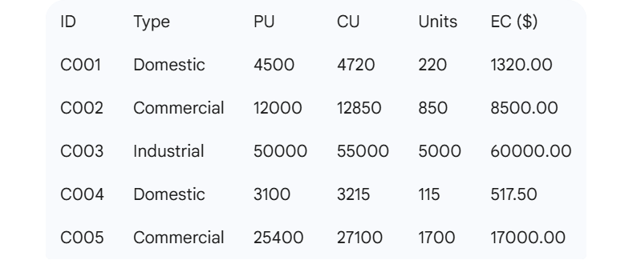

Task 3: Modular Design Using AI Assistance (Using Functions)
Scenario
Billing logic must be reusable for multiple consumers.
Task Description
Use AI assistance to generate a Python program that:
• Uses user-defined functions to:
o Calculate Energy Charges
o Calculate Fixed Charges
• Returns calculated values
• Includes meaningful comments

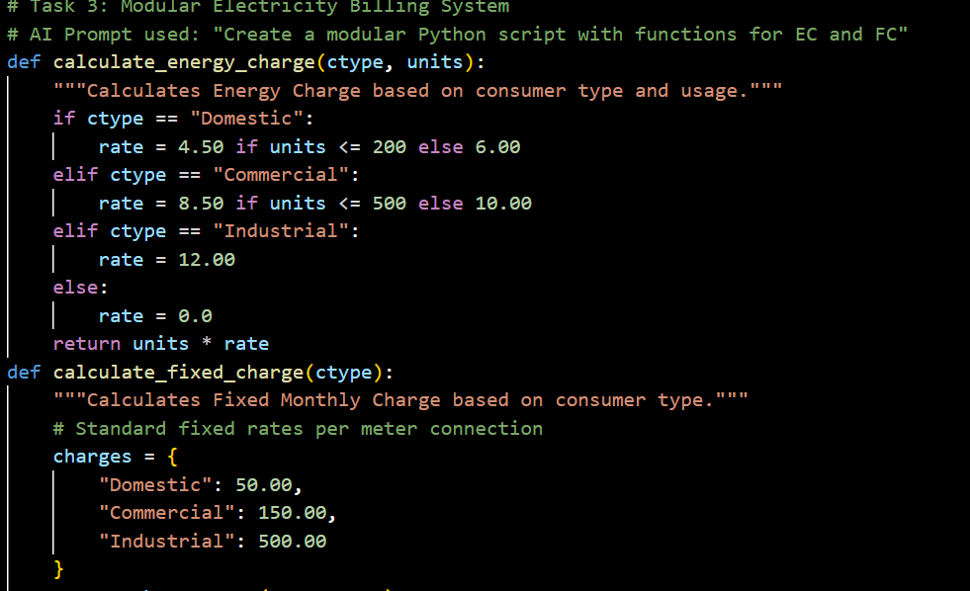

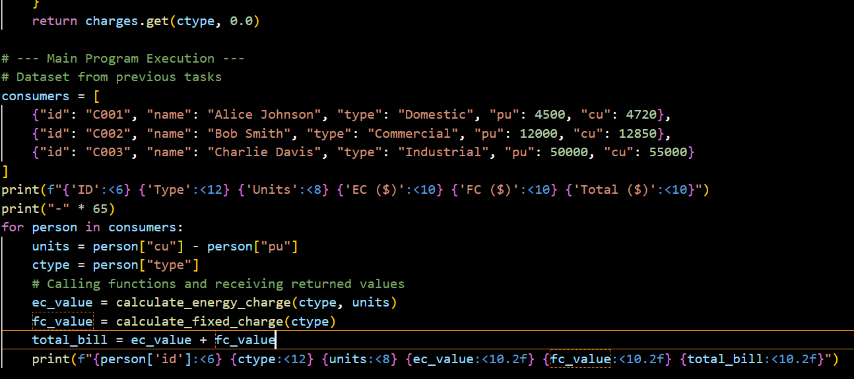
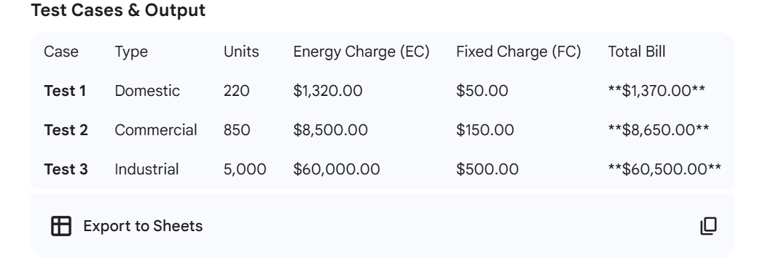

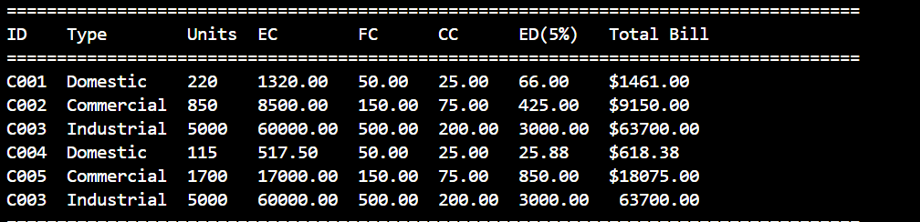

Task 4: Calculation of Additional Charges
Scenario
Electricity bills include multiple additional charges.
Task Description
Extend the program to calculate:
• FC – Fixed Charges
• CC – Customer Charges
• ED – Electricity Duty (percentage of EC)
Use AI prompts like:
• “Add electricity duty calculation”
• “Improve billing accuracy

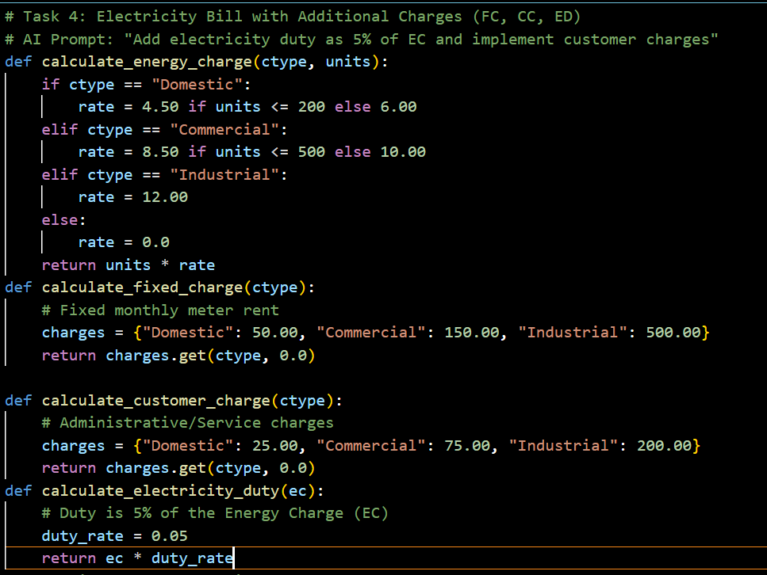

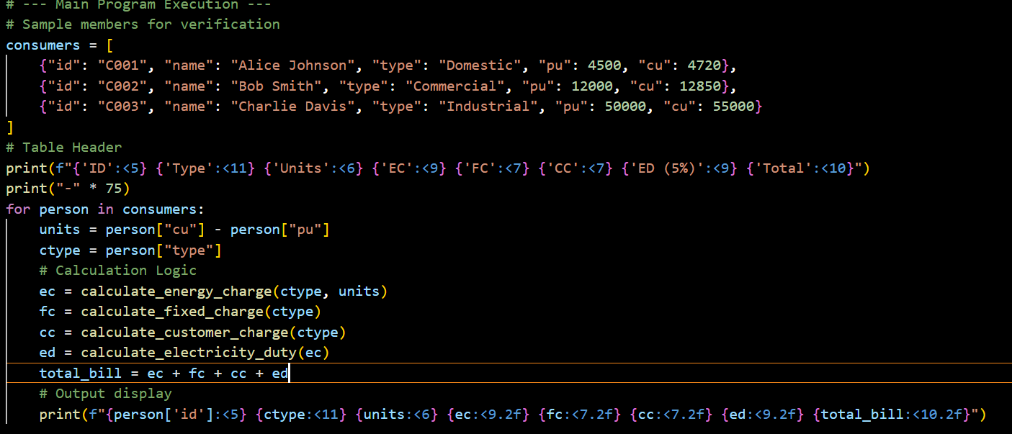

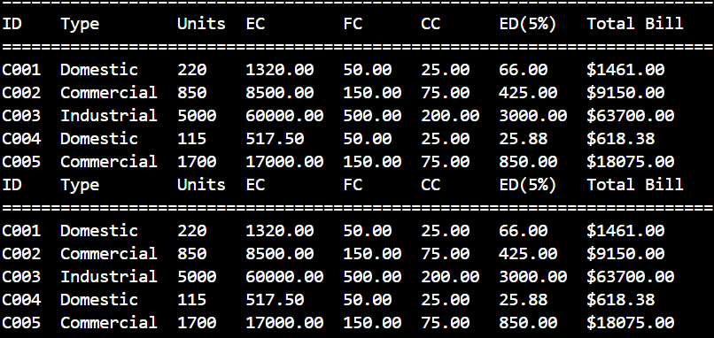

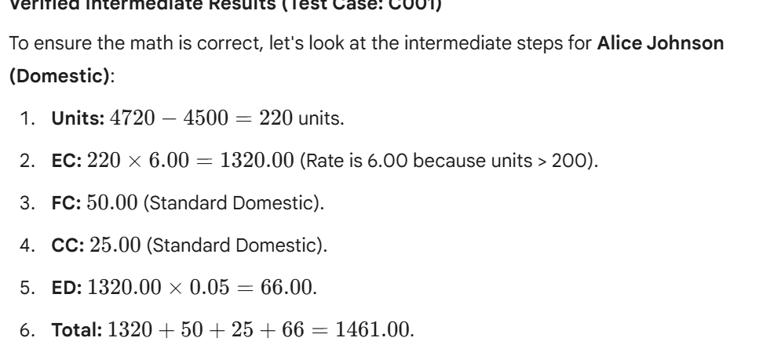

Task 5: Final Bill Generation and Output Analysis
Scenario
The final electricity bill must present all values clearly.
Task Description
Develop the final Python application to:
• Calculate total bill:
• Total Bill = EC + FC + CC + ED
• Display:
o Energy Charges (EC)
o Fixed Charges (FC)
o Customer Charges (CC)
o Electricity Duty (ED)
o Total Bill Amount
• Analyze the program based on:
o Accuracy
o Readability
o Real-world applicability

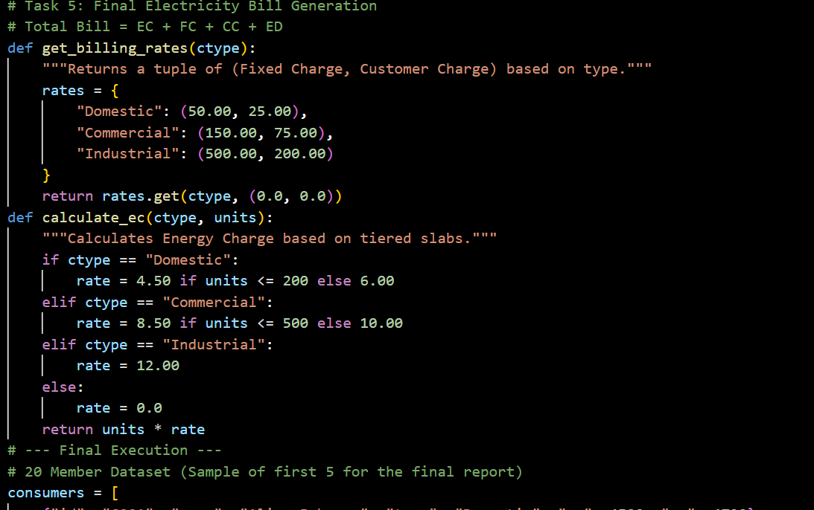

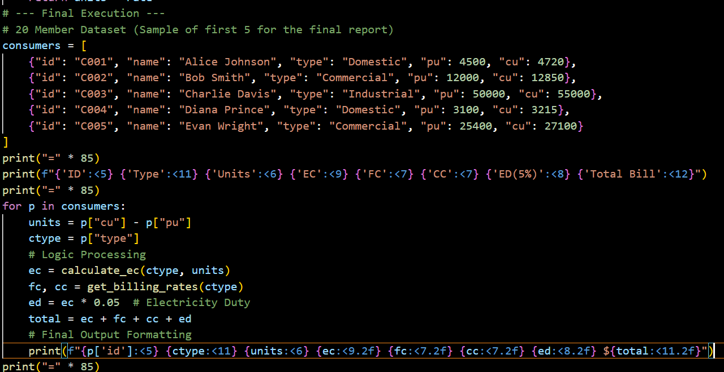

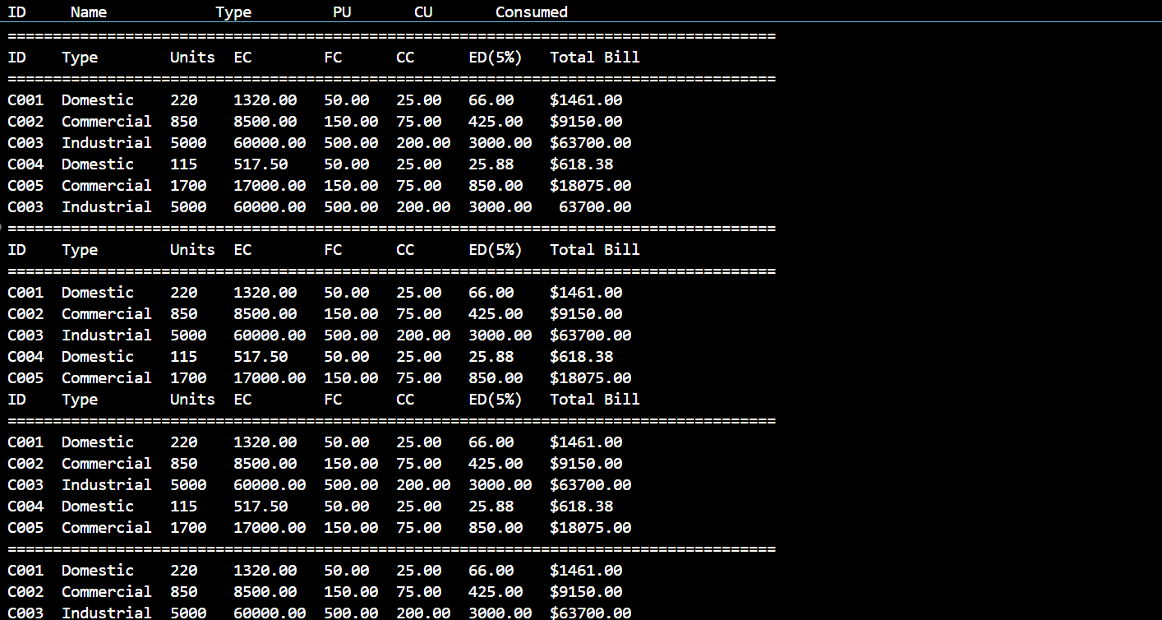
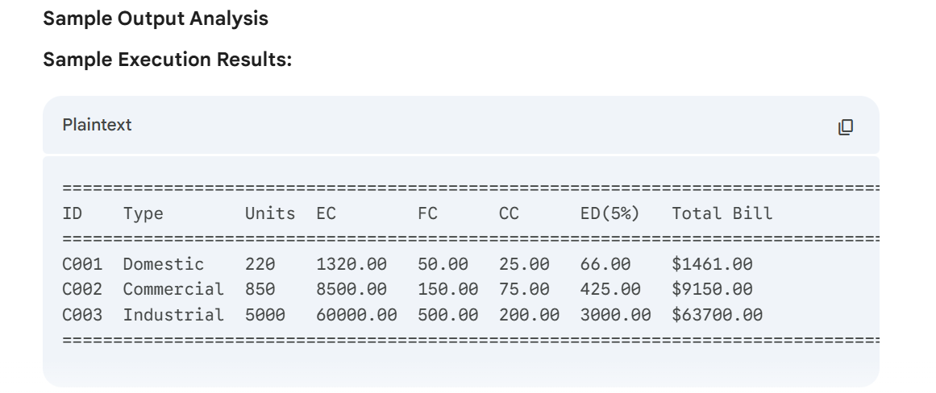

Program Analysis:
Short Analysis Paragraph: The final application demonstrates high accuracy by correctly applying tiered energy rates and secondary charges based on specific customer categories. The code's readability is significantly improved through modularization, using distinct functions for charge logic which makes the script easier to maintain. In terms of real-world applicability, the program mirrors actual utility billing cycles by separating fixed infrastructure costs from consumption-based costs and legal duties, providing a scalable template for commercial software development.

